Lab # 02
Basic Syntax, Input/Output, Data Types
& Arithmetic Operations in C++
Objective:
To understand the basic structure of a C++ program, perform input/output operations, use different data types, and apply arithmetic operators.
Theory:
1. Basic Syntax of C++
A c++ program follows a specific structure:

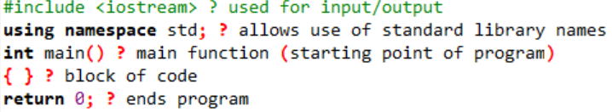
2. Input and Output in C++
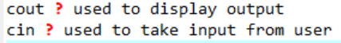
Example:
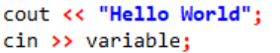
3. Data Types in C++
Data types define the type of data a variable can store:
Data Type
Description
Example:
- Int
- 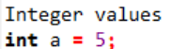

- Float

- 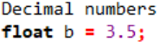
- Double
- 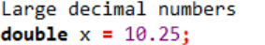
- Char
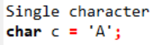
- String
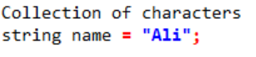
4. Arithmetic Operators
Used to perform mathematical operations:
Operator
Meaning
Example
- +

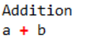

- -
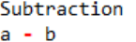
- *
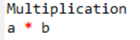
- Division
- %
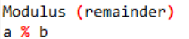
Program:
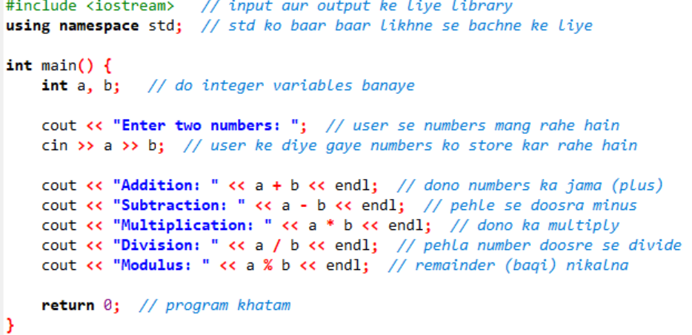
Explanation:
- Two integers a and b are declared.
- User inputs values using cin.
- Arithmetic operations are performed.
- Results are displayed using cout.
Sample Output:
Enter two numbers: 10 5
Addition: 15
Subtraction: 5
Multiplication: 50
Division: 2
Modulus: 0
Conclusion:
In this lab, we learned:
- Structure of a C++ program
- How to take input and display output
- Different data types
- Use of arithmetic operators
Precautions:
- Always use semicolon ; at end of statements
- Avoid division by zero
- Use correct data types.

Lab Tasks:
(1):
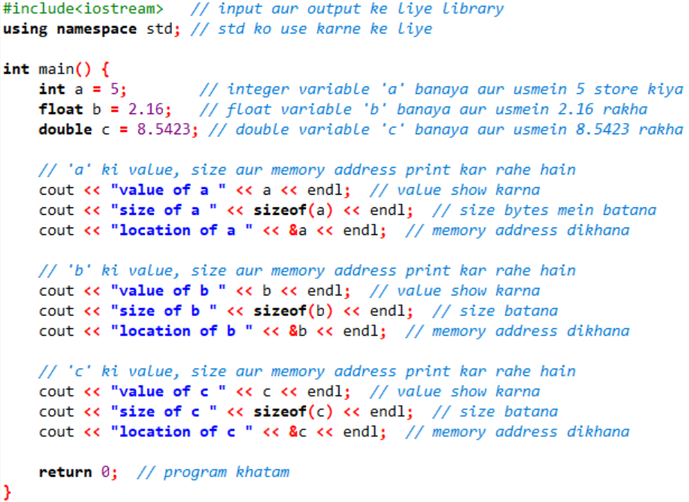

(2):
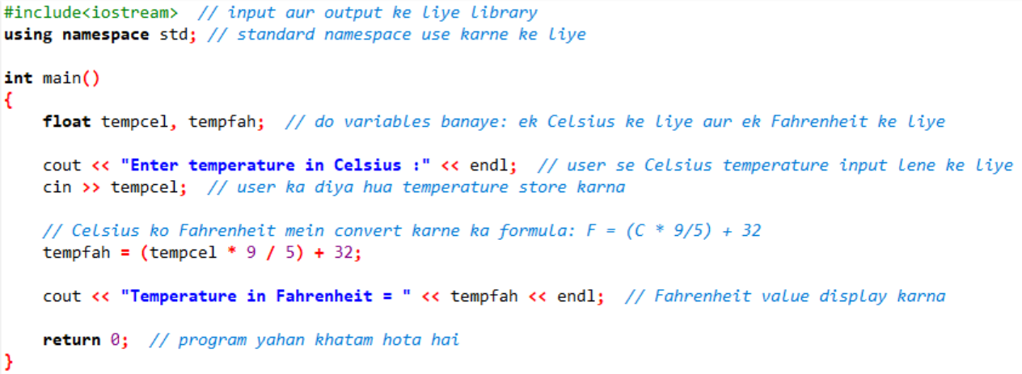

(3):
